**EXP 12**) Create a Virtual Machine with 1 CPU, 2GB RAM and 15GB storage disk using a Type 2 Virtualization Software

**PROCEDURE:**

**STEP 1:** install VM ware software

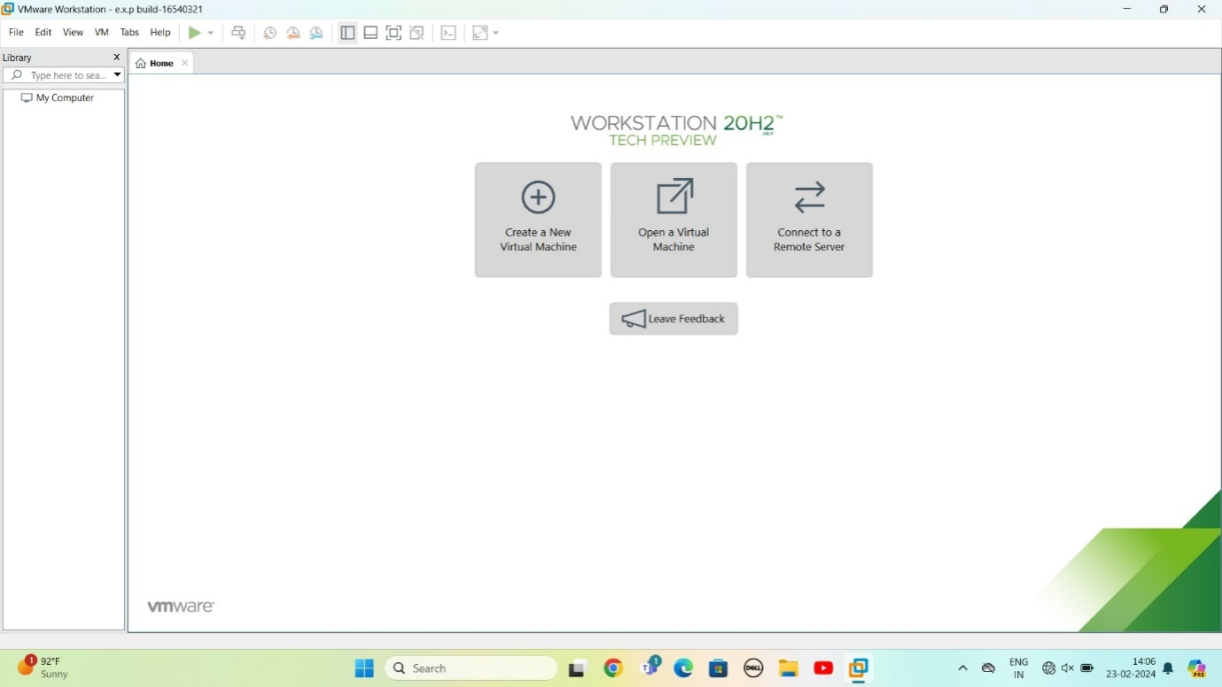

Step 2: CREAT A NEW VIRTUAL MACHINE

GIVE NEXT

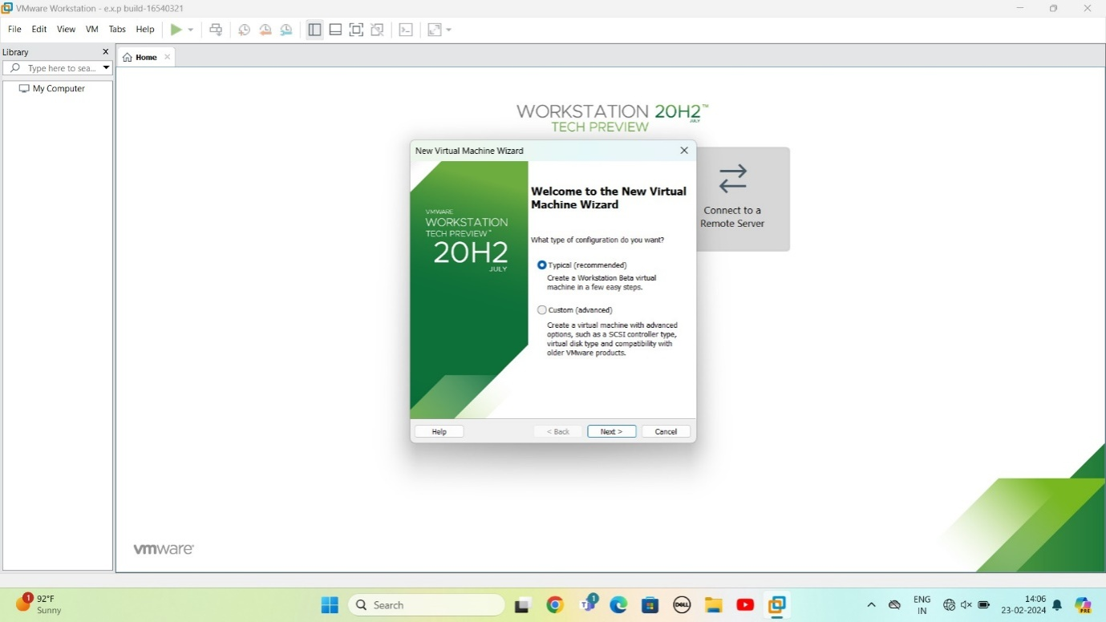

STEP 3:Select I will install operating system later

Give next

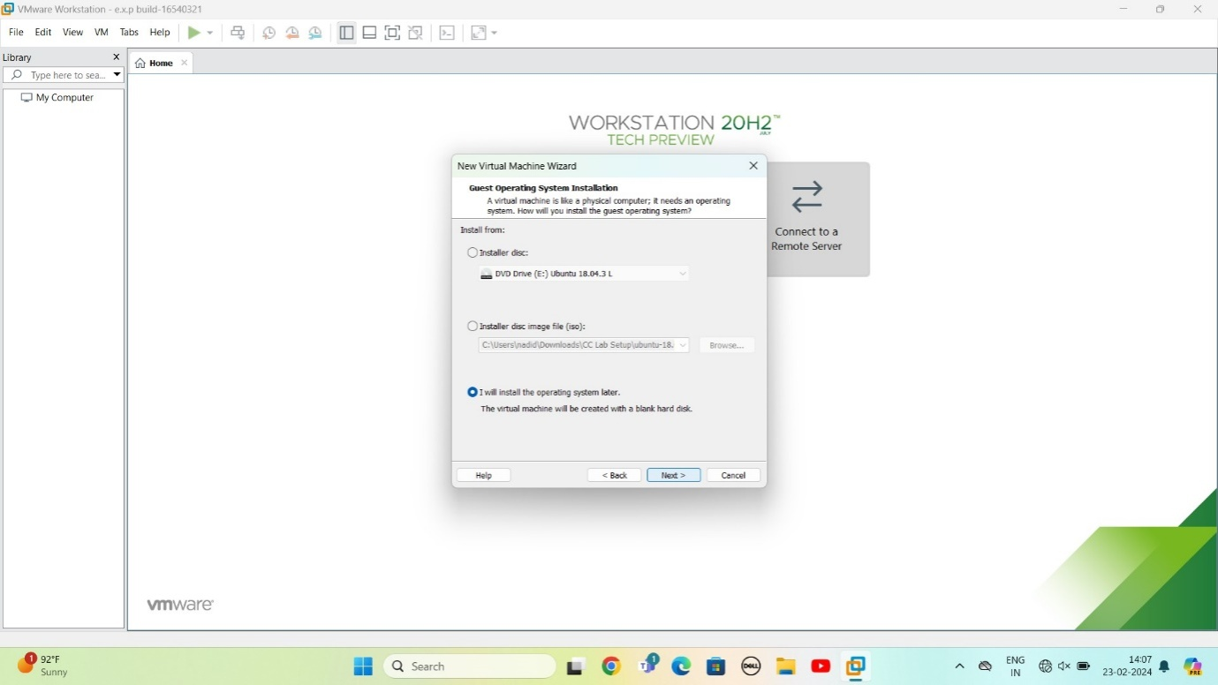

STEP 4: Select gust operating system

Give next

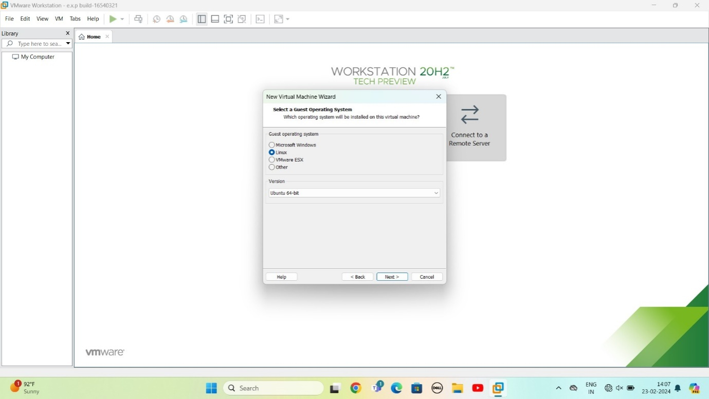

STEP 5: select name of virtual machine

Give next

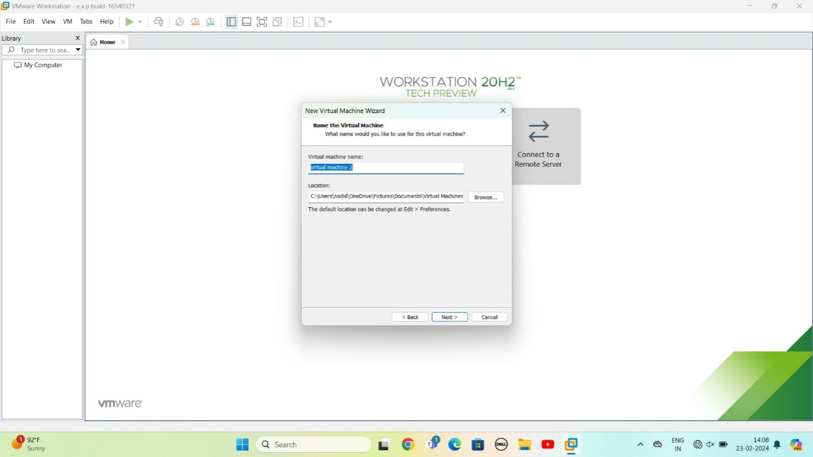

STEP 6: select the data storing disk and maximum size of disk

IN question they given maximum size=15.0 change value

Give next

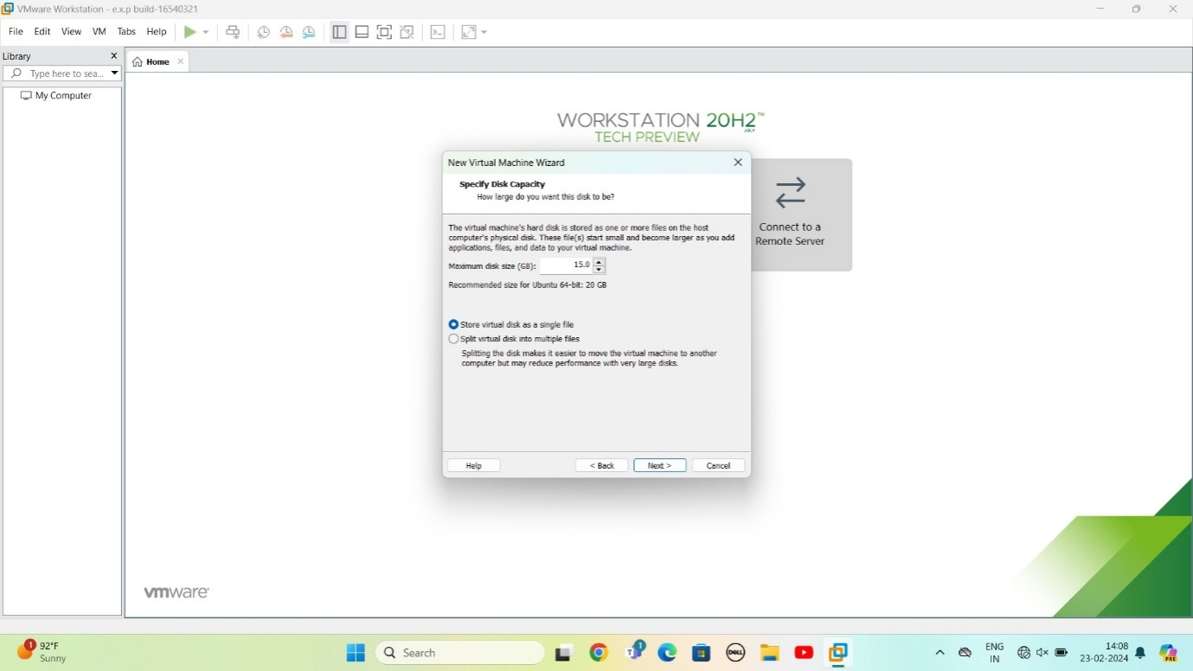

STEP 7:Ready to create virtual machine

Give finish

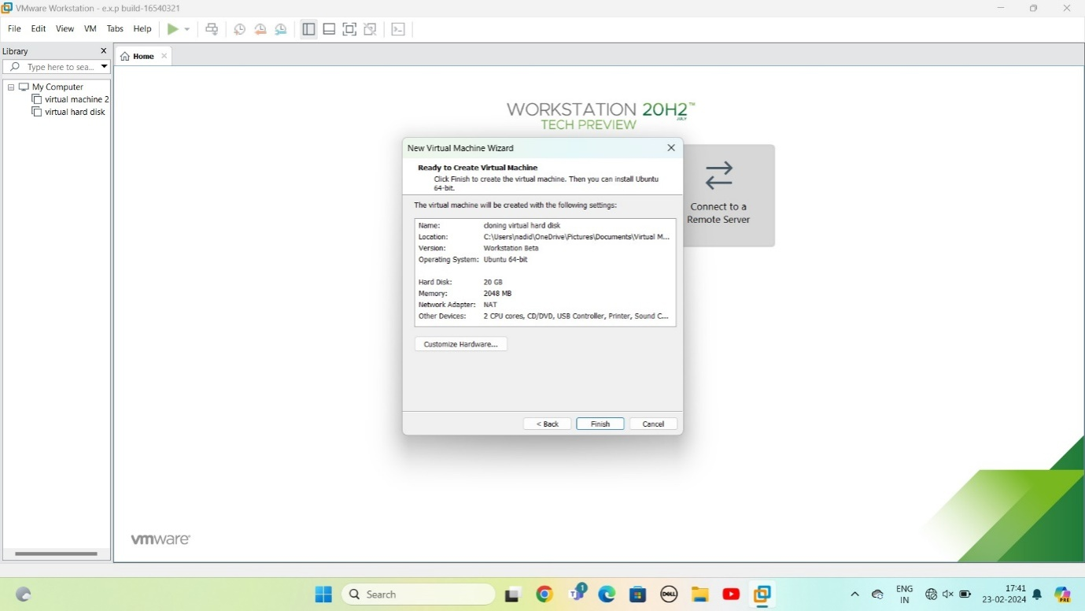

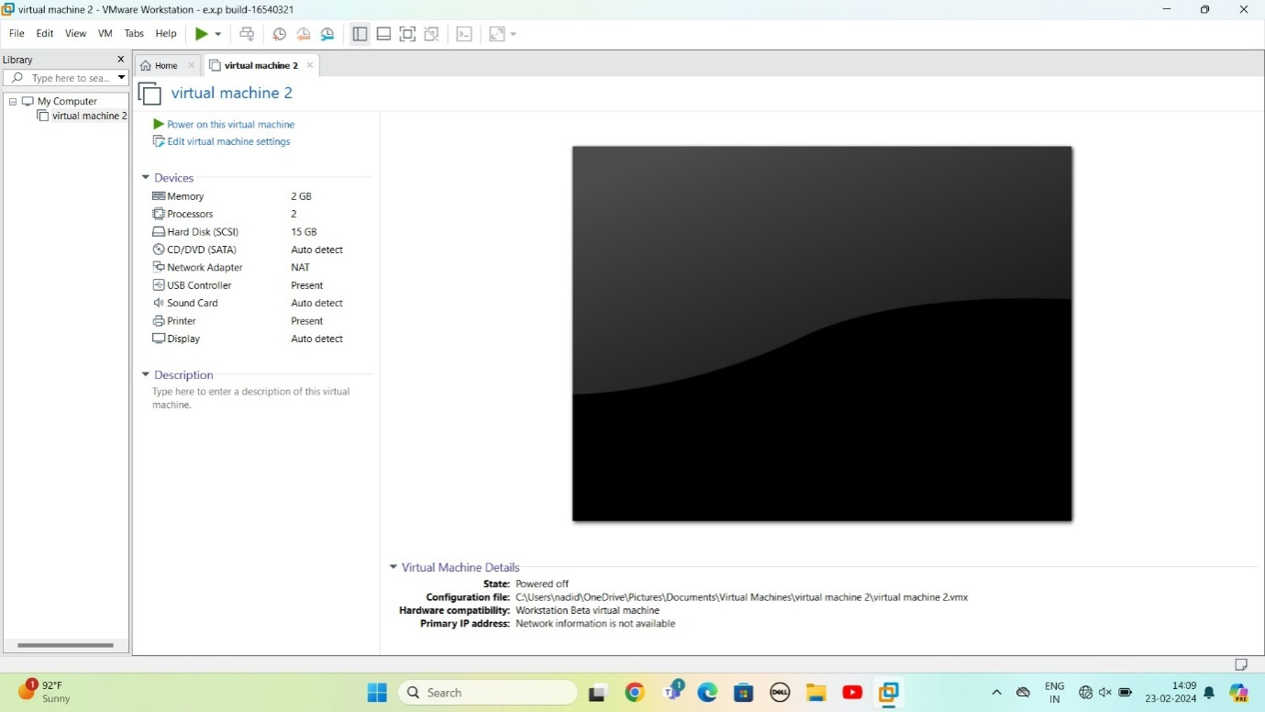

STEP 9: In problem they given CPU value =1

Change according to it

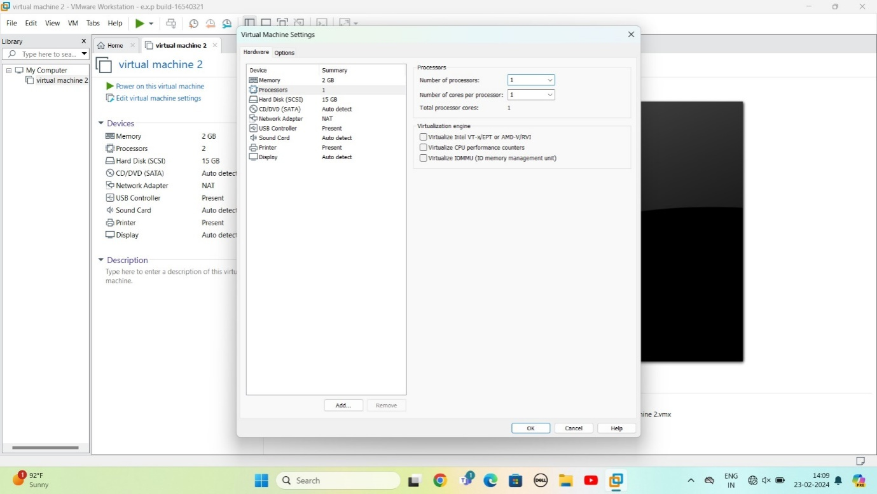

STEP 10: change RAM=2gb

And complete virtual machine as per given question

